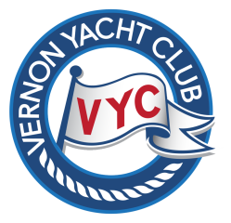
Vernon Yacht Club
28th BOAT & WATERSPORTS SHOW
May 6th & 7th 2017
Celebrating Canada’s 150th!

2017 Boat Show Vendor Advertisement Order Form
These advertising rates reflect the 25% discount for Boat Show Vendors for the April/May 2017 issue only. The Boat Show Tiller Topics is mailed to VYC members, printed for the Boat Show visitors and posted on the website.
Deadline for your ad submission is April 15th, 2017!
Choose Ad size for 8.5’x11’ page:
1/4 page: $30 + $1.50 GST (regular $40)

1/3 page (horizontal only): $45 + $2.25 GST (regular $60)

1/2 page: $60 + $3.00 GST (regular $80)

Ad Format:
Submit your advertisement text by email as a Word document, and submit Pictures and Logos as pdf or jpeg files to: tiller@vernonyachtclub.com.

Advertisement Order Form Submission:
Print, complete and fax this order form to fax: 250-545-0388 or scan and email it to: office@vernonyachtclub.com If paying by cheque, please mail your cheque to: VYC Boat Show c/o Office Manager, Vernon Yacht Club, 7919 Okanagan Landing Road, Vernon, B.C. V1H 1H1
Billing Information:
Date:
Company Name:
Contact Person:
Vernon Yacht Club Member? : | Yes |  |  | No
Billing Address:

Email Address:
Phone Number:
Please pre-pay for all ads: |  | MasterCard |  | Visa
MC or Visa # |  | Expiry Date:
For additional information please contact:
Vernon Yacht Club phone: 250-545-5518 or Betty Day (Tiller Topics) email: tiller@vernonyachtclub.com
Fax form to: 250-545-0388 or scan + email to: office@vernonyachtclub.com

